Q1. Implement the Binary search algorithm regarded as a fast search algorithm with run-time complexity of Ο(log n) in comparison to the Linear Search.

CODE :

#include <iostream>

using namespace std;

int main(){

    int num,ele,low,mid,high;

    cout<<"Please enter how many elements to be enetered into the array:    ";

    cin>>num;

    int arr[num];

    cout<<"Please enter the elements in a sorted manner\n";

    for(int i = 0;i<num;i++){

        cin>>arr[i];

    }

    low = 0;

    high = num-1;

    bool found = false;

    cout<<"Please eneter the element to be found:   ";

    cin>>ele;

    while(low<=high){

        mid = (low+high)/2;

        if(arr[mid]==ele){

            cout<<"The element was found at "<<mid+1<<" position";

            found = true;

            break;

        }

        else if(arr[mid]>ele){

            high = mid-1;

        }

        else{

            low = mid+1;

        }

    }

    if(found == false){

        cout<<"Element not present in the array";

    }

}

OUTPUT:

Q2. Bubble Sort is the simplest sorting algorithm that works by repeatedly swapping the adjacent elements if they are in wrong order. Code the Bubble sort with the following elements:

CODE:

#include <iostream>

using namespace std;

int main(){

    int num,i,j,temp;

    cout<<"Please enter how many elements to be entered into the array:    ";

    cin>>num;

    int arr[num];

    cout<<"Please enter the elements in the array:  ";

    for(int i = 0;i<num;i++){

        cin>>arr[i];

    }

    for(i=0;i<num;i++){

        for(j=0;j<num-i-1;j++){

            if(arr[j]>arr[j+1]){

                temp = arr[j];

                arr[j] = arr[j+1];

                arr[j+1] = temp;

            }

        }

    }

    cout<<"Sorted array:    ";

    for(int i = 0;i<num;i++){

        cout<<arr[i]<<" ";

    }

}

OUTPUT:

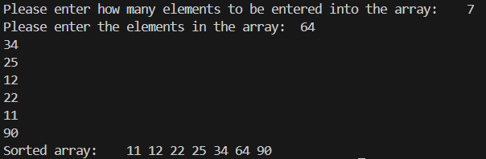

Q3. Design the Logic to Find a Missing Number in a Sorted Array.

CODE:

#include <iostream>

using namespace std;

int main(){

    int arr[4] = {2,3,5,6};

    for(int i =0;i<4;i++){

        if(arr[i+1] != arr[i]+1){

            cout<<"The missing number is:   "<<arr[i]+1;

            break;

        }

    }

}

OUTPUT:



Q4(a). Write a program to concatenate one string to another string.

CODE:

#include <iostream>

using namespace std;

int main(){

    string s1,s2;

    s1 = "Hello";

    s2 = "World";

    cout<<s1+s2;

}

OUTPUT:



Q4(b). Write a program to reverse a string.

CODE:

#include <iostream>

#include <string>

using namespace std;

int main(){

    string s1,s2;

    cout<<"Please enter a string:   ";

    getline(cin,s1);

    for(int i=s1.length()-1;i>=0;i--){

        s2 += s1[i];

    }

    cout<<s2;

}

OUTPUT:



Q4 (c).  Write a program to delete all the vowels from the string.

CODE:

#include <iostream>

#include <string>

using namespace std;

int main(){

    string s1,s2;

    cout<<"Please eneter a string:  ";

    getline(cin,s1);

    for(int i=0;i<s1.length();i++){

        if(s1[i]=='a'||s1[i]=='A'||s1[i]=='e'||s1[i]=='E'||s1[i]=='i'||s1[i]=='I'||s1[i]=='o'||s1[i]=='O'||s1[i]=='u'||s1[i]=='U'){

            continue;

        }

        else{

            s2+=s1[i];

        }

    }

    cout<<s2;

}

OUTPUT:



Q4 (d). Write a program to sort the strings in alphabetical order.

CODE:

#include <iostream>

#include <string>

#include <algorithm>

using namespace std;

int main(){

    string s1;

    cout<<"Please enter a string:   ";

    getline(cin,s1);

    sort(s1.begin(), s1.end());

    cout<<s1;

}

OUTPUT:



Q4 (e). Write a program to convert a character from uppercase to lowercase.

CODE:

#include <iostream>

#include <string>

using namespace std;

int main(){

    string s1;

    cout<<"Please enter a string:   ";

    getline(cin,s1);

    for(int i=0;i<s1.length();i++){

        if(65<=s1[i]&& s1[i]<=90){

            s1[i] += 32;

        }

    }

    cout<<s1;

}

OUTPUT:



Q5(a). Diagonal Matrix.

CODE:

#include <iostream>

using namespace std;

int main(){

    int num;

    cout<<"Please enter the size of the matrix:  ";

    cin>>num;

    int arr[num];

    cout<<"Please enter the diagonal elements:  ";

    for(int i=0;i<num;i++){

        cin>>arr[i];

    }

    cout<<"The 2D matrix is:    "<<"\n";

    for(int i=0;i<num;i++){

        for(int j=0;j<num;j++){

            if(i==j){

                cout<<arr[i]<<" ";

            }

            else{

                cout<<"0"<<" ";

            }

        }

        cout<<"\n";

    }

}

OUTPUT:

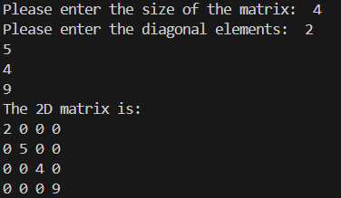

Q5.(b) Tri-diagonal Matrix.

CODE:

#include <iostream>

using namespace std;

int main(){

    int num;

    cout<<"Please enter the size of the matrix: ";

    cin>>num;

    int size = 3\*num-2;

    int arr[size];

    cout<<"Please enter the elements in the array:   ";

    for(int i=0;i<size;i++){

        cin>>arr[i];

    }

    cout<<"The 2D matrix is:    \n";

    int k = 0;

    for(int i=0;i<num;i++){

        for(int j=0;j<num;j++){

            if(i==j){

                cout<<arr[k]<<" ";

                k++;

            }

            else if(i-j==-1){

                cout<<arr[k]<<" ";

                k++;

            }

            else if(i-j==1){

                cout<<arr[k]<<" ";

                k++;

            }

            else{

                cout<<"0"<<" ";

            }

        }

        cout<<"\n";

    }

}

OUTPUT:

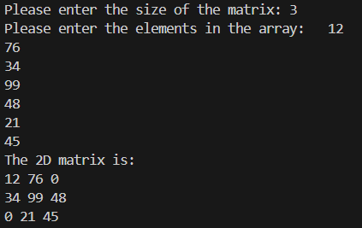

Q5. (c) Lower triangular Matrix.

CODE:

#include <iostream>

using namespace std;

int main(){

    int num;

    cout<<"Please enter the size of the matrix: ";

    cin>>num;;

    int size = ((num\*(num+1))/2);

    int arr[size];

    cout<<"Please enter the elements in the array:   ";

    for(int i=0;i<size;i++){

        cin>>arr[i];

    }

    cout<<"The 2D matrix is:    \n";

    int k=0;

    for(int i=0;i<num;i++){

        for(int j=0;j<num;j++){

            if(i>=j){

                cout<<arr[k]<<" ";

                k++;

            }

            else{

                cout<<"0"<<" ";

            }

        }

        cout<<"\n";

    }

}

OUTPUT:

Q5. (d) Upper triangular Matrix.

CODE:

#include <iostream>

using namespace std;

int main(){

    int num;

    cout<<"Please enter the size of the matrix: ";

    cin>>num;;

    int size = ((num\*(num+1))/2);

    int arr[size];

    cout<<"Please enter the elements in the array:   ";

    for(int i=0;i<size;i++){

        cin>>arr[i];

    }

    cout<<"The 2D matrix is:    \n";

    int k=0;

    for(int i=0;i<num;i++){

        for(int j=0;j<num;j++){

            if(i<=j){

                cout<<arr[k]<<" ";

                k++;

            }

            else{

                cout<<"0"<<" ";

            }

        }

        cout<<"\n";

    }

}

OUTPUT:

Q5. (e) Symmetric Matrix

CODE:

#include<iostream>

using namespace std;

int main(){

    int num;

    cout<<"Enter the size of the matrix:    ";

    cin>>num;

    int size=(num\*(num+1))/2;

    int arr[size];

    cout<<"Enter the elements of array: ";

    for(int i=0;i<size;i++){

        cin>>arr[i];

    }

    cout<<"The 2D matrix is:    \n";

    int b[num][num];

    int k=0;

    for(int i=0;i<num;i++){

        for(int j=0;j<num;j++){

            if(i<=j){

                b[i][j]=arr[k];

                k++;

            }

        }

    }

    for(int i=0;i<num;i++){

        for(int j=0;j<num;j++){

            if(i>j){

                b[i][j]=b[j][i];

            }

        }

    }

    for(int i=0;i<num;i++){

        for(int j=0;j<num;j++){

            cout<<b[i][j]<<" ";

        }

        cout<<"\n";

    }

}

OUTPUT:

Q6. (a) Transpose of a matrix.

CODE:

#include <iostream>

using namespace std;

int main() {

int row, col;

int trans[100][3];

int s[100][3];

cout << "Enter the number of rows of array: ";

cin >> row;

cout << "Enter the number of columns of array: ";

cin >> col;

int arr[row][col];

cout << "Enter the elements of array:\n";

for (int i = 0; i < row; i++) {

for (int j = 0; j < col; j++) {

cin >> arr[i][j];

}

}

cout << "\nOriginal Matrix:\n";

for (int i = 0; i < row; i++) {

for (int j = 0; j < col; j++) {

cout << arr[i][j] << " ";

}

cout << "\n";

}

int k = 1;

for (int i = 0; i < row; i++) {

for (int j = 0; j < col; j++) {

if (arr[i][j] != 0) {

s[k][0] = i;

s[k][1] = j;

s[k][2] = arr[i][j];

k++;

}

}

}

s[0][0] = row;

s[0][1] = col;

s[0][2] = k - 1;

cout << "\nSparse Matrix (Triplet form):\n";

cout << "Row Column Value\n";

for (int i = 0; i < k; i++) {

cout << s[i][0] << " " << s[i][1] << " " << s[i][2] << "\n";

}

int x = 1;

for (int i = 0; i < s[0][1]; i++) {

for (int j = 1; j <= s[0][2]; j++) {

if (s[j][1] == i) {

trans[x][0] = s[j][1];

trans[x][1] = s[j][0];

trans[x][2] = s[j][2];

x++;

}

}

}

trans[0][0] = s[0][1];

trans[0][1] = s[0][0];

trans[0][2] = s[0][2];

cout << "\nTranspose of Sparse Matrix:\n";

cout << "Row Column Value\n";

for (int i = 0; i < k; i++) {

cout << trans[i][0] << " " << trans[i][1] << " " << trans[i][2] << "\n";

}

}

OUTPUT:

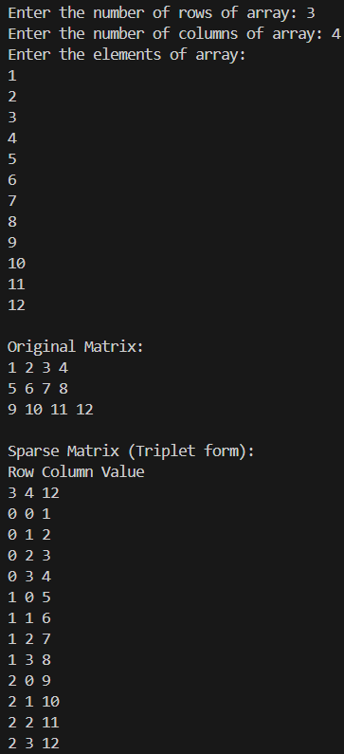

Q6. (b)  Addition of two matrices.

CODE:

#include <iostream>

using namespace std;

int main() {

int row, col, arr1[100][100], arr2[100][100];

int s1[100][3], s2[100][3], add[200][3];

cout << "Enter the number of rows: ";

cin >> row;

cout << "Enter the number of columns: ";

cin >> col;

cout << "Enter elements of Matrix 1:\n";

for (int i = 0; i < row; i++)

for (int j = 0; j < col; j++)

cin >> arr1[i][j];

cout << "Enter elements of Matrix 2:\n";

for (int i = 0; i < row; i++)

for (int j = 0; j < col; j++)

cin >> arr2[i][j];

int k = 1, z = 1;

for (int i = 0; i < row; i++)

for (int j = 0; j < col; j++) {

if (arr1[i][j] != 0) {

s1[k][0] = i;

s1[k][1] = j;

s1[k][2] = arr1[i][j];

k++;

}

if (arr2[i][j] != 0) {

s2[z][0] = i;

s2[z][1] = j;

s2[z][2] = arr2[i][j];

z++;

}

}

s1[0][0] = s2[0][0] = row;

s1[0][1] = s2[0][1] = col;

s1[0][2] = k - 1;

s2[0][2] = z - 1;

cout << "\nSparse Matrix 1 (Row Col Value):\n";

for (int i = 0; i < k; i++)

cout << s1[i][0] << " " << s1[i][1] << " " << s1[i][2] << "\n";

cout << "\nSparse Matrix 2 (Row Col Value):\n";

for (int i = 0; i < z; i++)

cout << s2[i][0] << " " << s2[i][1] << " " << s2[i][2] << "\n";

int m = 1, i = 1, j = 1;

add[0][0] = row;

add[0][1] = col;

while (i < k && j < z) {

if (s1[i][0] < s2[j][0] || (s1[i][0] == s2[j][0] && s1[i][1] < s2[j][1])) {

for (int p = 0; p < 3; p++)

add[m][p] = s1[i][p];

i++;

m++;

} else if (s2[j][0] < s1[i][0] || (s1[i][0] == s2[j][0] && s2[j][1] < s1[i][1])) {

for (int p = 0; p < 3; p++)

add[m][p] = s2[j][p];

j++;

m++;

} else {

int sum = s1[i][2] + s2[j][2];

if (sum != 0) {

add[m][0] = s1[i][0];

add[m][1] = s1[i][1];

add[m][2] = sum;

m++;

}

i++;

j++;

}

}

while (i < k) {

for (int p = 0; p < 3; p++)

add[m][p] = s1[i][p];

i++;

m++;

}

while (j < z) {

for (int p = 0; p < 3; p++)

add[m][p] = s2[j][p];

j++;

m++;

}

add[0][2] = m - 1;

cout << "\nAddition Result (Sparse Matrix Form):\n";

for (int idx = 0; idx < m; idx++)

cout << add[idx][0] << " " << add[idx][1] << " " << add[idx][2] << "\n";

}

OUTPUT:

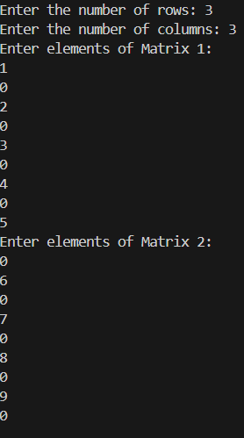

Q6 (c)

CODE:

#include <iostream>

using namespace std;

int main() {

int r1, c1, r2, c2;

int arr1[100][100], arr2[100][100];

int s1[100][3], s2[100][3], trans[100][3], mult[100][3];

cout << "Enter rows and columns for matrix 1: ";

cin >> r1 >> c1;

cout << "Enter rows and columns for matrix 2: ";

cin >> r2 >> c2;

if (c1 != r2) {

cout << "Multiplication not possible\n";

return 0;

}

cout << "Enter elements of matrix 1:\n";

for (int i = 0; i < r1; i++)

for (int j = 0; j < c1; j++)

cin >> arr1[i][j];

cout << "Enter elements of matrix 2:\n";

for (int i = 0; i < r2; i++)

for (int j = 0; j < c2; j++)

cin >> arr2[i][j];

int k = 1;

for (int i = 0; i < r1; i++)

for (int j = 0; j < c1; j++)

if (arr1[i][j] != 0) {

s1[k][0] = i;

s1[k][1] = j;

s1[k][2] = arr1[i][j];

k++;

}

s1[0][0] = r1;

s1[0][1] = c1;

s1[0][2] = k - 1;

int z = 1;

for (int i = 0; i < r2; i++)

for (int j = 0; j < c2; j++)

if (arr2[i][j] != 0) {

s2[z][0] = i;

s2[z][1] = j;

s2[z][2] = arr2[i][j];

z++;

}

s2[0][0] = r2;

s2[0][1] = c2;

s2[0][2] = z - 1;

int x = 1;

for (int col = 0; col < s2[0][1]; col++)

for (int i = 1; i <= s2[0][2]; i++)

if (s2[i][1] == col) {

trans[x][0] = s2[i][1];

trans[x][1] = s2[i][0];

trans[x][2] = s2[i][2];

x++;

}

trans[0][0] = s2[0][1];

trans[0][1] = s2[0][0];

trans[0][2] = s2[0][2];

int m = 1;

for (int i = 1; i <= s1[0][2]; i++) {

for (int j = 1; j <= trans[0][2]; j++) {

if (s1[i][1] == trans[j][1]) {

int r = s1[i][0];

int c = trans[j][0];

int val = s1[i][2] \* trans[j][2];

int found = 0;

for (int p = 1; p < m && !found; p++) {

if (mult[p][0] == r && mult[p][1] == c) {

mult[p][2] += val;

found = 1;

}

}

if (!found) {

mult[m][0] = r;

mult[m][1] = c;

mult[m][2] = val;

m++;

}

}

}

}

mult[0][0] = r1;

mult[0][1] = c2;

mult[0][2] = m - 1;

cout << "Resultant Sparse Matrix (Multiplication):\n";

cout << "Row Col Value\n";

for (int i = 0; i < m; i++)

cout << mult[i][0] << " " << mult[i][1] << " " << mult[i][2] << "\n";

}

OUTPUT:

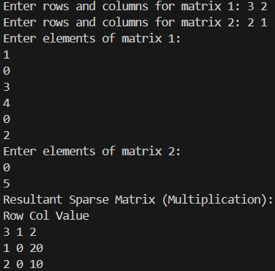

Q7. Let A[1 …. n] be an array of n real numbers. A pair (A[i], A[j ]) is said to be an inversion if these numbers are out of order, i.e., i < j but A[i]>A[j ]. Write a program to count the number of inversions in an array.

CODE:

#include <iostream>

using namespace std;

int main(){

    int num;

    cout<<"Please enter the number of elements in the array:    ";

    cin>>num;

    int arr[num];

    for(int i=0;i<num;i++){

        cin>>arr[i];

    }

    int countInversions = 0;

    for(int i=0;i<num;i++){

        for(int j=i+1;j<num;j++){

            if(arr[i]>arr[j]){

                countInversions+=1;

            }

        }

    }

    cout<<"Counted Inversions:  "<<countInversions;

}

OUTPUT:

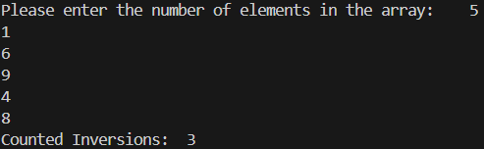

Q8. Write a program to count the total number of distinct elements in an array of length n.

CODE:

#include <iostream>

using namespace std;

int main(){

    int num;

    cout<<"Please enter the number of elements in the array:    ";

    cin>>num;

    int arr[num];

    for(int i=0;i<num;i++){

        cin>>arr[i];

    }

    int countUnique = 0;

    for(int i=0;i<num;i++){

        bool unique = true;

        for(int j=0;j<i;j++){

            if(arr[i]==arr[j]){

                unique = false;

                break;

            }

        }

        if(unique == true){

            countUnique += 1;

        }

    }

    cout<<"Number of unique elements:   "<<countUnique;

}

OUTPUT:

